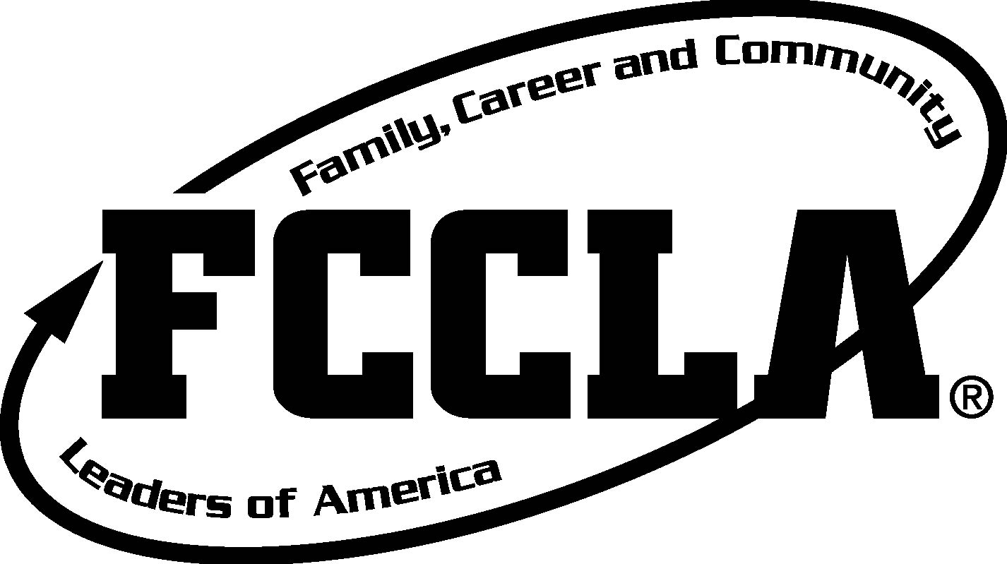

exploringfacs.weebly.com

Dear Parents and Students,

Leadership development is an important part of the Family and Consumer Sciences curriculum areas because young people need leadership skills to succeed in the workplace and in the home. Family, Career, and Community Leaders of America (FCCLA) builds leaders for healthy families, successful careers and strong communities. It is a dynamic and effective national student organization that helps young men and women become leaders and address important personal, family, work and societal issues through Family and Consumer Sciences education.

Students who are currently taking a Family and Consumer Sciences (FACS) class may participate in in-class FCCLA chapter projects throughout the semester. All FACS students are invited to participate in after school club meetings. Many of these activities will take students beyond the classroom through assignments and/or service projects within the community. These projects and activities are an important part of your student’s total learning experience. Your student will be encouraged to pay dues and become a state and nationally affiliated FCCLA member. Paying dues opens a wide variety of opportunities and offers the pride of belonging to an important national organization. FCCLA opportunities and advantages include leadership development, community service, recognition, travel and expanded learning opportunities.

This is the second year Salem Middle School has had a FCCLA chapter but this my ninth year as an adviser and my sixth year traveling with students to conferences and competitive events. In 2013 (at Ligon Middle School) 16 students competed at the state level in Greensboro, NC and 8 competed at the national level in Nashville, TN!! In 2014, 8 students traveled to state conference where 3 students won the chance to complete at the national level in San Antonio, TX. Last year (2015) 4 students traveled to state conference and 2 competed on Washington, DC at the National Leadership Conference! Affiliated students will have the chance to complete a personal project (STAR Event) and compete at the state (Greensboro, NC) and national (San Diego, CA) level. Students will be recognized for their project research, hard work, dedication and awards received locally and statewide.

All students who are currently taking Family Focus or Consumer Focus are eligible to join. FCCLA will meet once a month (or more if needed) on Mondays after school in room 501 (Ms. Anderson’s room). Meetings will be from 3:00-4:00 (longer if needed, I will email the upcoming meeting agenda and meeting time in advance). You must plan to have a ride pick you up by 4:00 (after school activity buses are not an option as they arrive later). Please make sure you listen to morning and afternoon announcements for upcoming meetings!

Meeting dates for first semester: Aug 10, Sept 14, Oct 12, Nov 9, and Dec 14

If you would like to affiliate with FCCLA on the state and national levels please fill out the attached form and return to me, Ms. Anderson, by Monday, August 10, 2015. The first meeting will be held in room 501 on Monday, August 10th. FCCLA dues are $19.00 total, which includes your state and national dues. If you would like a Salem Middle School FCCLA tshirt we will explore options and collect money at a later time. Please pay your dues online (or bring cash/check) and complete the attached form on or before the first meeting.

State and National Affiliated Members:
Travel Expenses
Students who affiliate with FCCLA will also have the opportunity to work on a personal (individual or group) project and travel to the state conference to present his/her project. Interested members must attend a District 3 (Wake County’s district within all of NC’s FCCLA organizations) Leadership Meeting (November 24, 2015). This meeting will cost each student $10 (includes registration, transportation to Nash Community College in Rocky Mount, NC and lunch). You will be excused from school on this day. Transportation will be provided by Wake County for all events but parents will be responsible for getting their student to and from the assigned pick up location at the scheduled time. More information/forms about this year’s District 3 Meeting will be provided soon.

Students who place first or second place at the NC State Leadership Conference in Greensboro, NC (April 11-13, 2016) will have the opportunity to compete at the National Leadership Conference this summer (July 3rd-7th, 2016) in San Diego, CA!! State conference (in Greensboro) costs each student about $140 (includes registrations, dance, 2 nights hotel, and transportation) and national conference (in CA) cost each student about $800 (includes registrations, hotel, transportation, dance/gala, and city tours).

Remember Wake County CTE Department will pay for student transportation (bus tickets, plane tickets, etc.)!

Travel opportunities are optional! You can be a member of FCCLA and only participate in the local/school activities or you can get totally involved and have the opportunity to experience all of what FCCLA has to offer through projects, competition, conferences and travel!

I am looking forward to another successful chapter of FCCLA! This is a great opportunity to get to know your fellow students, yourself and your school. I hope you will join FCCLA and attend the first meeting on Monday, August 10th 3:00-4:00pm! Thanks in advance for your support and participation!

Thanks,

Sarah Anderson, FCCLA Master Adviser
Salem FCCLA’s website: exploringfacs.weebly.com
NC FCCLA: ncfccla.org
National FCCLA: fcclainc.org

“FCCLA has been a great experience for my daughter...community service, camaraderie, excellent teacher leadership, travel opportunities, and more!” –Meredith Pope, parent

“I loved all that you did.” –Karen Rosser, parent

"Last year(2012) my daughter participated in the FCCLA Nationals for the first time. She had an amazing experience! I always felt that she was well-supervised, but she had a tremendous feeling of independence - it was the best of both worlds for her. When she talks about it now, you can see the pride on her face and hear it in her voice. In particular, she says how great it felt to represent North Carolina in a national setting. It was a wonderful opportunity for her to step out on her own, gain confidence and deepen friendships."-Gaye Hill, parent

"I enjoyed the kids in Florida and got a real sense that they were committed to doing their best and putting in the required work to achieve it." –Rick Marcotte, parent

"This has been an amazing experience and great leadership skills for the kids."-Carole Marcotte, parent

"Just got home from Competition in Greensboro! We got SILVER but sadly will not be competing at the National level in Tennessee this summer! Nationals was such a life changing experience last year and I would like to Congratulate everyone who is advancing to the next level! I had an amazing time with some of the best people and cannot wait to compete again next year!" -Emma O'Brien, former member

Member Information

Complete and return to Ms. Anderson on or before August 10, 2015. Dues ($19) are also due when you return this form.

We will be using OSP (Online School Payments, flyer attached) this year as an option for paying all dues and travel payments. Please visit http://osp.osmsinc.com/wakeNC to set up your profile and make your chapter dues payment. You can also send in cash or write a check to Salem Middle School. The activity number/code is: AG116-38. You can also pay by cash or check to Salem Middle.

Student Name: _________________________________________ Grade: ____ Track: ____
Birthday: ___________________ (if you are under the age of 13 there is an addition form to complete)

T-shirt size: _______ (adult small, medium, large or extra large)
Would you like a SMS FCCLA t-shirt for an additional cost? ______ (yes or no)

1st period/Homeroom Teacher: _____________________________

Parent(s)/Guardian Name: ___________________________________________

Contact information:
Home phone number: _____________________________

Parent’s cell number: _____________________________

Student’s cell number: _____________________________

Home address: _____________________________
Street address
_____________________________
City state zip code
E-mail address: _____________________________
(student email)

_____________________________
(parent email)

I am allowing my student to join FCCLA at the state and national level and I am aware that he/she will have to stay after school once a month (or more if needed) on Mondays for meetings and projects. I also understand the cost involved in traveling with FCCLA. My student will also be involved in community service projects, fundraisers and possibly competitions and conferences!

Parent signature: _______________________________________ Date: _______________
Thank you so much for your support!!!

